Project 11: IR Remote Control Smart Car
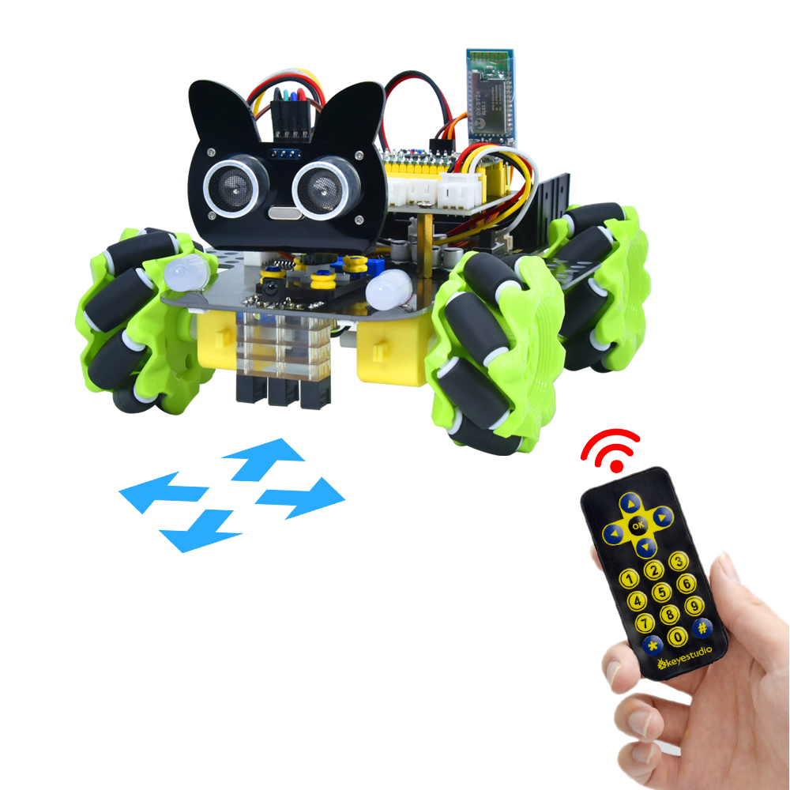

1. Description
In this project, we will work to control the car using an IR remote control.

- Flow Diagram
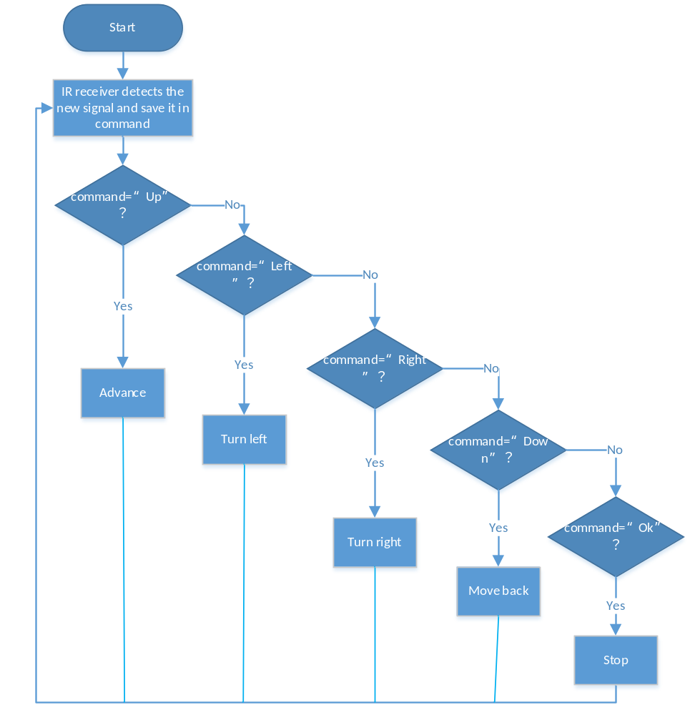

3. Test Code
'''
Keyestudio 4WD Mecanum Robot for Pico
lesson 11
IRremote Control Robot
http://www.keyestudio.com
'''

from machine import Pin,I2C
import mecanumCar_v2
import time

i2c = I2C(0, sda = Pin(20), scl = Pin(21), freq = 400000) #iic0 sda-->20,scl-->21
mecanumCar = mecanumCar_v2.Driver(i2c) #Create a driver instance for the car

ird = Pin(6,Pin.IN) #IR receiver pin interface is GPIO6

#IR decoder dictionary
act = {"1": "LLLLLLLLHHHHHHHHLHHLHLLLHLLHLHHH","2": "LLLLLLLLHHHHHHHHHLLHHLLLLHHLLHHH","3": "LLLLLLLLHHHHHHHHHLHHLLLLLHLLHHHH",
"4": "LLLLLLLLHHHHHHHHLLHHLLLLHHLLHHHH","5": "LLLLLLLLHHHHHHHHLLLHHLLLHHHLLHHH","6": "LLLLLLLLHHHHHHHHLHHHHLHLHLLLLHLH",
"7": "LLLLLLLLHHHHHHHHLLLHLLLLHHHLHHHH","8": "LLLLLLLLHHHHHHHHLLHHHLLLHHLLLHHH","9": "LLLLLLLLHHHHHHHHLHLHHLHLHLHLLHLH",
"0": "LLLLLLLLHHHHHHHHLHLLHLHLHLHHLHLH","Up": "LLLLLLLLHHHHHHHHLHHLLLHLHLLHHHLH","Down": "LLLLLLLLHHHHHHHHHLHLHLLLLHLHLHHH",
"Left": "LLLLLLLLHHHHHHHHLLHLLLHLHHLHHHLH","Right": "LLLLLLLLHHHHHHHHHHLLLLHLLLHHHHLH","Ok": "LLLLLLLLHHHHHHHHLLLLLLHLHHHHHHLH",
"*": "LLLLLLLLHHHHHHHHLHLLLLHLHLHHHHLH","#": "LLLLLLLLHHHHHHHHLHLHLLHLHLHLHHLH"}

def read_ircode(ird):
wait = 1
complete = 0
seq0 = []
seq1 = []

while wait == 1:
if ird.value() == 0:
wait = 0
while wait == 0 and complete == 0:
start = time.ticks_us()
while ird.value() == 0:
ms1 = time.ticks_us()
diff = time.ticks_diff(ms1,start)
seq0.append(diff)
while ird.value() == 1 and complete == 0:
ms2 = time.ticks_us()
diff = time.ticks_diff(ms2,ms1)
if diff > 10000:
complete = 1
seq1.append(diff)

code = ""
for val in seq1:
if val < 2000:
if val < 700:
code += "L"
else:
code += "H"
# print(code)
command = ""
for k,v in act.items():
if code == v:
command = k
if command == "":
command = code
return command

while True:
command = read_ircode(ird)
if command == "Up":
mecanumCar.Advance()
elif command == "Down":
mecanumCar.Back()
elif command == "Left":
mecanumCar.Turn_Left()
elif command == "Right":
mecanumCar.Turn_Right()
elif command == "Ok":
mecanumCar.stop()

4.Test Result
Uploading the test code and powering up. When we press the button 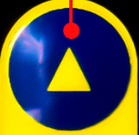on the remote control, the car moves forward, then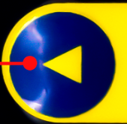, the car turns left, , the car moves back, , the car turns right, , the car stops.

5. Code Explanation

command = read_ircode(ird) | IR remote decodes, and the key values will be saved in command
if command == "Up": | The car will go forward
elif command == "Down": | The car will move back
elif command == "Left": | The car will turn left
elif command == "Right": | The car will turn right
elif command == "Ok": | The car will stop

